Hkkjr ljdkj
GOVERNMENT OF INDIA
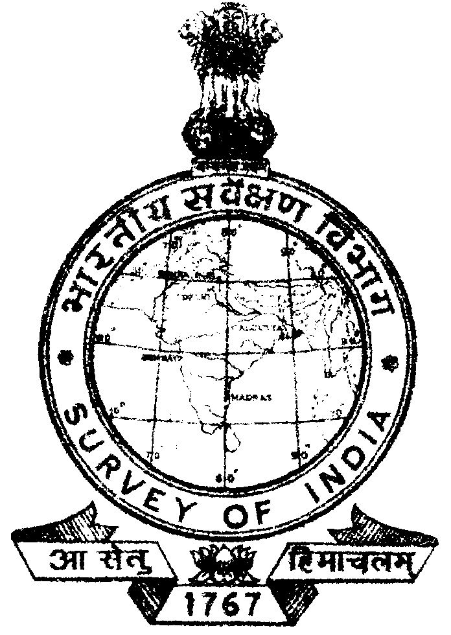
iQSDl Fax : 0172-2604671
nwjHkk”k Telephone : dk;kZy; Office: 0172-2602607
0172-2600031

Email : phc.gdc.soi @gov.in

la0 S 90@15-CPB
iatkc] gfj;k.kk ,oa p.Mhx<+
Hkw&LFkkfud vkadM+k dsUnz
Punjab, Haryana &Chandigarh
Geo-Spatial Data Centre
Hkkjrh; losZ{k.k foHkkx
SURVEY OF INDIA

lSDVj 32&,] p.Mhx<+ & 160030-

Sector 32-A, Chandigarh – 160030.
Dated : 03 March, 2015

CORRIGENDUM

Tender No. 65 dated 24-02-2015 in the Annexure ‘D’ financial bid in the column of service tax is to be read as 14% instead of 12.36%


(PANKAJ MISHRA)
DIRECTOR,
CHAIRMAN
COMBINED PROCUREMENT BOARD
PUNJAB, HARYANA & CHA NDIGARH GDC
SURVEY OF INDIA

